# Aflevering 1

Af Jesper Graungaard Bertelsen, AU-ID: au689481

Indholdsfortegnelse

Aflevering 1 1

Question 1 2

Question 2 4

Question 3 5

Question 4 8

## Question 1

On a set of cubic conventional unit cells, draw the following lattice planes with two lattice

planes on each conventional unit cell.  
(a) (1, -1, 0)

(b) (-1, 0, 2)

(c) (1, 1, -1)

(d) (2, -1, 0)

(e) (-2, -1, -2)

First of all I wish to no what I’m supposed to see.   
Interceptions: $nul\left(h, k, l\right)≔\left[\begin{aligned}\frac{1}{h} \\ \frac{1}{k} \\ \frac{1}{l}\end{aligned}\right]$

For those with zero, that computation doesn’t work:

Now for plotting.   
a & d seems simular, I will plot those together  
a: $\left(1, \overline{1}, 0\right)$ $d:\left(2, \overline{1}, 0\right)$



I’ve moved them both by y = 1 to compensate for them intersecting at $y=-1.$

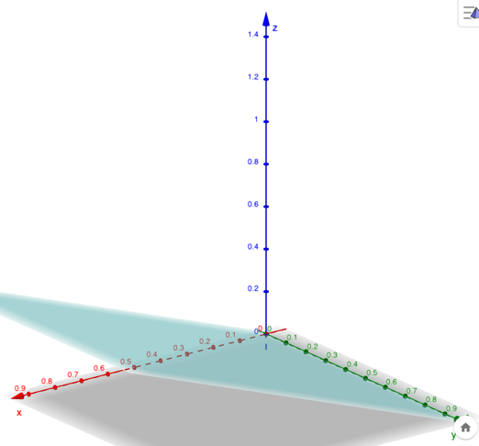Then plotting b & c.

Again, moving alongside the axis which has a minus component. $e:\left(\overline{2}, \overline{1}, \overline{2}\right)$



This one was weird, as if I only moved x $\frac{1}{2}$ it would immediately go towards - on the y axis. I moved x 1 instead, which suited well as x moves -1/2 as y moves 1.



## Question 2

An electron trapped in a small box with infinite boundaries is initially in its ground state.It then absorbs a photon which excites it to the first excited state. The wavelength of this photon is λo. Then it absorbs another photon which excites it from the first to the second excited state. Express the wavelength of the second photon in terms of λo.

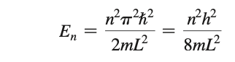This is an infinite well problem:

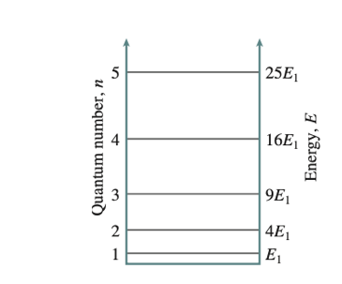

The author of my book has described it already.   
Going from stage 1 -> 2 requires 4 times the energy level at stage 1. Adding to the already energy level 1, we then need a wavelength which adds 3 times that for it to emit to the second level.

$E_{n}=\frac{n^{2}h^{2}}{8·m_{e}·L^{2}}$ $E_{foton}=\frac{hc}{λ}$

$\frac{hc}{λ_{0}}=E\left(1\right)$

$3·E\left(1\right)=>\frac{hc}{\frac{λ_{0}}{3}}$

So the wavelength of the second photon must be of size 3 times smaller than the first, wavelength.   
That seems like a correct answer

## Question 3

A ball of 2000 gram is moving at 150 m/s. A 3000 pound automobile is moving at 65

mile/hr. An oxygen molecule in air is moving at 107 cm/s. What is the kinetic energy (in

joule and electron-volt), de Broglie wavelength in meters and Plank frequency of these

moving objects? Which particle may require wave-quantum mechanics to explain its

motion and why?

Which one of the objects may require the wave-quantum mechanics to explain motion and why?

So this is a bunch of different things that we want to describe.   
With the last thing mentioned of which ones requiring quantum mechanics to describe them, let’s just dive into the classic physics first.

$E_{kin}\left(m;v\right)≔\frac{1}{2}·m·v^{2}$

$E_{kin}\left(m_{ball};v_{ball}\right)=22500 J$ $E_{kin}\left(m_{ball};v_{ball}\right)≈1,40434·{10}^{23} eV$ $$E_{kin}\left(m_{vehicle};v_{vehicle}\right)≈574956,4 J$$ $E_{kin}\left(m_{vehicle};v_{vehicle}\right)≈3,5886·{10}^{24} eV$ $E_{kin}\left(m_{molecule};v_{molecule}\right)≈1,32843·{10}^{-16} J$ $E_{kin}\left(m_{molecule};v_{molecule}\right)≈8,291415·{10}^{2} eV$

$λ_{de}=\frac{h}{p}$ $<-p=mv$

$λ_{de}\left(m;v\right)≔\frac{h}{m·v}$

$λ_{de}\left(m_{ball};v_{ball}\right)≈2,20869·{10}^{-36} m$ $λ_{de}\left(m_{vehicle};v_{vehicle}\right)≈1,67505·{10}^{-38} m$ $λ_{de}\left(m_{molecule};v_{molecule}\right)≈2,49395·{10}^{-13} m$

$$Slet definitioner:$$

So this is where it becomes weird. So by the de broglie wavelength we are trying to describe the wavelength of the matter of larger objects. This seems very odd, but by that reason we take our energy from our classic physics into the relative physics.

If I want to relate it to the planck frequency then I would want to change my de broglie wavelength into a de broglie frequency.   
For wave like behaviors we describe this as:

$$f\left(v;λ\right)≔\frac{v}{λ}$$

$$F_{p}=\frac{1}{2π}·\sqrt{\frac{c^{5}}{\frac{h}{2π}·G}}≈2,952·{10}^{42}Hz$$

$$F_{p}≔2,952·{10}^{42}Hz$$

Then the $\frac{f}{F_{p}}$ should give the fraction of the planck frequency.

$v_{molecule}≔{10}^{5}\frac{m}{s};v_{ball}≔150\frac{m}{s}; v_{vehicle}≔104,65·\frac{1000}{3600}·\frac{m}{s}$

================================================================

$$\frac{f\left(v_{ball}; 2,20869·{10}^{-36} m\right)}{F_{p}}≈2,300595·{10}^{-5}=0,0023\%$$

$$\frac{f\left(v_{vehicle};1,67505·{10}^{-38} m \right)}{F_{p}}≈5,878853·{10}^{-4}=0,059\% \\ \frac{f\left(v_{molecule};2,49395·{10}^{-13} m\right) }{F_{p}}≈1,3583·{10}^{-25}=1,35·{10}^{-23}\%$$ ================================================================

If it makes sense? I’m not totally sure.

But it seems a little odd, that we take to large objects and try to describe them with physics, that’s used to describe particles.

Looking at the chart I brought up in the introduction:

$$\frac{v_{molecule}}{3·{10}^{8}\frac{m}{s}}≈3,333333·{10}^{-4}$$

Doesn’t really come close to relativity being relevant. But I think it does have a place when using de broglie and trying to define it’s wave characteristics.   
For the ball and the car however, I don’t think they have a place being described like a particle.

=============================================  
None of them should be described using relativity  
The ball and the car shouldn’t be described as a particle   
=============================================

## Question 4

The electron affinity is defined as the amount of energy released when an electron is added to a neutral atom to form an anion. It measures the attraction between the incoming electron and the nucleus. The electron affinity of an isolated silicon atom is 1.39 eV while that of a neutral crystal is 4.02 eV. Explain why the electron affinity is larger for the silicon crystal.

Imagine one silicon atom. It has affinity towards getting an electron more, but is alone in its search for one.   
Now when looking at the silicon crystal grid, more atoms goes together to pull in the electron, thus increasing the electron affinity.